**Business Problem**

This project primarily deals with exploration and segmentation of neighborhoods in the city of London, United Kingdom.

I’m targeting investors and/or potential individual owners who are looking to invest in a restaurant business.

By means of this project, I’ll be focusing on aspects such as property price, population density and cuisine to facilitate the decision making process of our customer.

Using various data sources from the internet and by exploiting the location data facility of the foursquare API, I’ll begin by helping the customer narrow down his search for an appropriate location by considering the boroughs of London and discriminating on the basis of average property price and population density.

Once I have finalized the borough, I’ll explore its neighborhoods using the foursquare API to provide insights into what type of cuisine the residents typically enjoy, using which , I’ll cluster the neighborhoods into different categories. Our customer can then refer to these clusters which might help him decide what type of cuisine they would want their restaurant to serve and in which neighborhood they’d like to establish their business.

**Data**

Initially, the table of London Boroughs would be constructed by scraping the webpage <https://en.wikipedia.org/wiki/List_of_London_boroughs>

Their population densities would be scraped from their respective Wiki pages.

Further, I’ll use <https://www.foxtons.co.uk/living-in/> to extract the approximate property prices in the respective boroughs.

Once I have this data in the form of a table, I’ll choose the borough which best suits the budget requirement of the customer and has a reasonable density of population so as to expect a decent footfall.

Once the borough is finalized, I will construct a table which will contain the districts of the borough and their coordinates which would be fetched using the *geocoder* library of python.

Finally, I’ll use the *search* endpoint of the Foursquare API to get a list of restaurants in each district and construct a table with the columns indicating the type of restaurant(Indian,Japanese,Café,etc) and the rows indicating the neighborhood. Finally I’ll cluster these neighborhoods and display the most popular restaurant themes in each neighborhood within the clusters. This would help our customer narrow down their choice of neighborhood and the type of cuisine they wish to serve at their restaurant

**Methodology**

The initial focus of the project was to build a visualization which could give an overview of the Density and the average property prices in the various boroughs of London.

As discussed earlier, the first dataframe I intended to create was one that contained the names of boroughs, their average population densities and the average property prices within the boroughs.

For the borough names, I used BeautifulSoup to scrape the wiki page [*https://en.wikipedia.org/wiki/List_of_London_boroughs*](https://en.wikipedia.org/wiki/List_of_London_boroughs).

The names of all boroughs were contained in a table which I extracted into a bs4 object. Running a loop over all the rows, I filled the Borough column of my dataframe. Within the same loop, I filled the density column of my dataframe as well. In order to do this, I made an additional request to the Borough Name hyperlink in the wiki page being scraped, which opened the dedicated wiki page of that borough.

From their respective pages, I extracted the population density and appended it to the density column of the dataframe. Issues were encountered for two specific boroughs, for which I had to fill in the density values manually.

For the purpose of property prices, I took the help of [*https://www.foxtons.co.uk/living-in/*](https://www.foxtons.co.uk/living-in/)

A website dedicated to providing residents of all neighborhoods of London information including but not limited to property prices in their respective neighborhood. I was able to find out the information for most of the boroughs, but some boroughs were too large to be considered as consolidated units. So the website provided information not of those boroughs collectively, but of their sub districts individually. For the purpose of property price, I chose the most popular sub district within those boroughs to represent the collective average property price for that borough. This was supported by the evidence that the prices did not vary too much within a borough.

Once I had all the information in a dataframe, I visualized the results in the form of a dual axis plot, which clearly depicted the trend in terms of population density and property price.

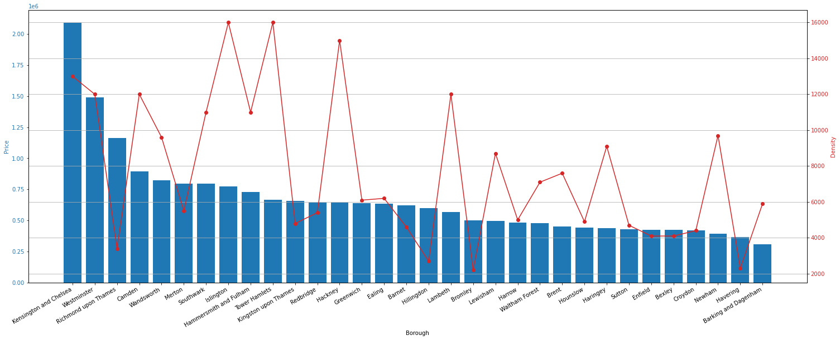

GBP 600000 and GBP 900000 which is a reasonable budget for someone looking to invest in a restaurant.

Also, the population density should be moderate to high as a low density would mean low footfall and a high density would probably lead to difficulty in finding space to open a restaurant. Refering to the graph, the **London borough of Hammersmith and Fulham** seemed to be a reasonable choice.

The next step was to create a new dataframe containing the various districts of Hamersmith and Fulham along with their coordinates.

I scraped the names of districts from the wiki page of London Borough of Hammersmith and Fulham which I further appended to the District column of my new Dataframe. Looping over the dataframe, I obtained the exact coordinates of the district using the geopy library, which I appended to the latitude and longitude columns.

The next step was to create a list of restaurants and their cuisines along with the district they’re located in. For this purpose, I looped over the district dataframe and made a call to the Foursquare API using the explore endpoint. The parameters passed included the CLIENT_ID ,CLIENT_SECRET ,VERSION ,RADIUS and SECTION(which is used if we wish to search for a specific type of venue. I provided ‘food’ in order to get a list of restaurants).

The resultant dataframe consisted of some duplicate values as the boundaries of districts are not very well defined and the API considers some restaurants to be part of multiple districts. In order to fix this, I used the remove_duplicates command.

In order to build a dataframe suitable for applying ML models, I transformed the existing dataframe into a sparse matrix such that the columns represented all the unique types of cuisines and the each individual row had the name of the district the restaurant was situated in and had a value ‘1’ in its respective cuisine column.

Next, I grouped the rows according to the district and summed up the column values. I thus obtained a dataframe which indicated the total number of restaurants of each category in every district.

Finally, I ran a K Means clustering algorithm on this data with k=3 which resulted in 3 clusters each with different districts. The cluster labels of each district were available using the method *kmeans.labels_*

The districts dataframe was modified by adding the cluster labels and including only the top 4 most common cuisines for every district.

On careful examination of the clusters, some conclusive results could be derived.

**Results**

The clusters obtained were as follows.

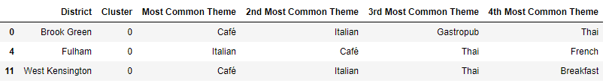

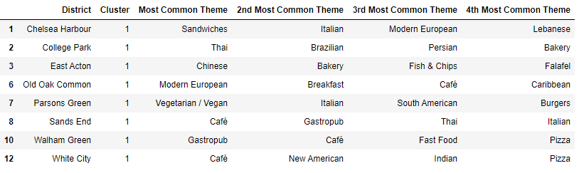

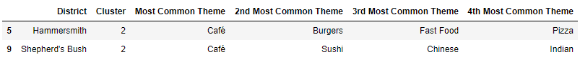

Following Conclusions can be drawn –

* The outer London boroughs have lower property prices but also have a low density of population which probably is not in favor of a footfall dependent business like a restaurant.
* Although the inner London boroughs have a high density of population and are popular among youth and tourists, they’re prohibitively expensive.
* Within the London borough of Hammersmith and Fulham, which we concluded is a reasonable choice to open a restaurant, Café is the most popular restaurant theme followed by Italian.
* For districts lying in the cluster 0, a Café with a predominantly Italian theme would be a good theme for a restaurant .
* Cluster 1 seems to have a somewhat varied distribution with café and Italian being the most common. Different districts seem to have their own favourite theme. If our customer wants to experiment and try a different unconventional theme, cluster 1 would be a good spot as it seems the residents of these districts are open to experimentation.
* In cluster 2, apart from cafes , fastfood would also be a good theme for a new restaurant.

**Conclusion**

To conclude, we can say that this project , although not perfect, provides a reasonably accurate picture of the city of London to a potential customer in terms of what to expect when venturing out to start a restaurant business.

The results will definitely provide a good headstart and will definitely help our customer narrow down his location search.

The project, if built upon , could be made more general in nature and could even be developed into an app with a provision for the user to enter the specific type of business and the country/city they wish to invest in. The project could also be modified to include the provision to enter specific parameters which the user considers as priority while planning to make an investment, eg – distance from city centre, average rents, government policies, etc.